S**indh Madressatul Islam University**

**Department of Software Engineering**

**2nd Semester Fall 2022**

**Software Engineering (SEN102)**

**Faculty Name: Syeda Wajiha Naim**

# **Assignment # 3 & 4**

**(Total Marks: 20)**

### **Deadline**

Your assignment must be submitted before or on **5th January 2023**.

### **Objective**

This assignment is designed to let you learn the concepts of software engineering.

### **Assignment**

1. As a project manager your job is to manage a team of developers that is going to build an application similar to the ones they have built earlier which means they have experience building such applications. The application that they are going to build now is more complex and larger one, and the requirements have been thoroughly explained and documented by the customer. Justify your choice of process model for this project. Discuss the valid reason(s) in detail.
2. Discuss T-shirt sizing technique of story points estimation in Agile.
3. Give example of Risk mitigation, monitoring and management (RMMM) plan. [Build up a table.]

**Instructions**

* Submit within due date.
* Write in your own words.
* On title page mention the following:

**Insert Logo of the University**

Underneath the logo write:

* Do not use rephrasing tool.

***SEMESTER/SECTION: 2(A)***

***SUBJECT: SOFTWARE ENGINEERING***

***COURSE CODE: SEN-102***

***Deadline: 5th Jan, 2023***

***SUBMITED TO: MS. WAJEEHA NAIM***

***SUBMITTED BY:***

***Muhammad Mubashir (BSE-22S-084)***

***ASSIGNMENT # 3 & 4***

## Translation Management Software

***Scenario:***

As a project manager your job is to manage a team of developers that is going to build an application similar to the ones they have built earlier which means they have experience building such applications. The application that they are going to build now is more complex and larger one, and the requirements have been thoroughly explained and documented by the customer. Justify your choice of process model for this project. Discuss the valid reason(s) in detail.

Which software process model(s) would you choose? Name the process model(s) and explain along with the diagram(s).

***OBJECT:***

According to this Scenario I have chosen **Water Fall Process Model.**

***WATERFALL PROCESS MODEL:***

***Definition:***

Water Fall Model used in System Development Life Cycle (SDLC). It is used to develop small projects and simple or easy. In this Model System develop with linear process and Model work on one phase to another phase in downward condition that's why it is called Water Fall Process Model.

**Explanation:**

Water fall model is a systematically linear approach. In development of project this model divided in different phases every phase performs a specific task with objectives. In this model next phase only start when previous phase is completed once you move next step you don’t back to previous step.

This Process Model based on five phases with perform different tasks. These five phases are following in below.

***Phases Of Water Fall Process Model:***

***Communication:***

In this phase of Water Fall you communicate with your team member's and gather requirement of project, problems of project through opinions of your all team member's and make a document or report of requirement like initial report and distributed to your team member's.

***Planning:***

After gathering of requirements, you need to understand requirements and find out their solution, so you discuss future work in this phase like timeline of project, how to work, what work do, how to run project etc.

***Modeling:***

After Planning of project, we make a design of project by established a requirements and review of model.

***Construction:***

In this phase of Water fall code take place and testing of code. Programmer's do code according to information of last phase and requirements of next phase then testing of code and find out problems or errors and solve in this step.

***Development:***

In this phase Project is complete and ready to deliverable in marketplace and take feedback from market.

***DIAGRAM OF WATERFALL PROCESS MODEL:***

Communication

Modeling

Planning

Development

Construction

***Advantages:***

* Every step fully complete before moving on next step
* In Every step making a documentation
* In the start of project requirement was well defined.
* It is easy or simple for small projects.

***Disadvantages:***

* Its is rigid model have no flexibility, no experiment and have risk.
* Once you move on next step you don’t back to previous step even you have any problem in last step.
* Clients do not change requirements once they defined.

Explain in detail why you have chosen that specific process model.

***Reasons:***

In this Scenario I have chosen water fall process model because according to this scenario Requirements is completely well defined from client, document of requirement is ready and no changes in requirements. And no changes in requirements also means that no move back last step once you move on next step or phase. Water fall model first way to communication and promote accurate information. completely documentation and design of project clearly defined in scenario .Because of no changes or well defined requirements team must completed each step before move back on next step And this all rules of Waterfall model that's why I have choose this.

2. Discuss T-shirt sizing technique of story points estimation in Agile.

**T-shirt sizing**T-shirt Sizing is one of the Story points sizing technique to estimate user story usually used in agile projects. It's a relative Estimation Technique.  
Rather than using a number of planning pokers, here, Items are classified into t-shirt sizes:

XS, S, M, L, XL.

The term originates from the way T-shirt sizes are indicated in the US. Rather than having T-shirts in sizes 4, 5, 6 etc, there are just a few sizes: Small (S), Medium (M), Large (L) and Extra Large (XL) and so on.  
  
With T-shirt measuring, the development team is made a request to evaluate whether they think a story is extra-small, small, medium, large, extra-large, or double extra-large. By expelling the numerical score, the development team is allowed to think in a more dynamic manner about the exertion associated with a story. The sizes can, if necessary, be given numerical value after the estimation is finished.

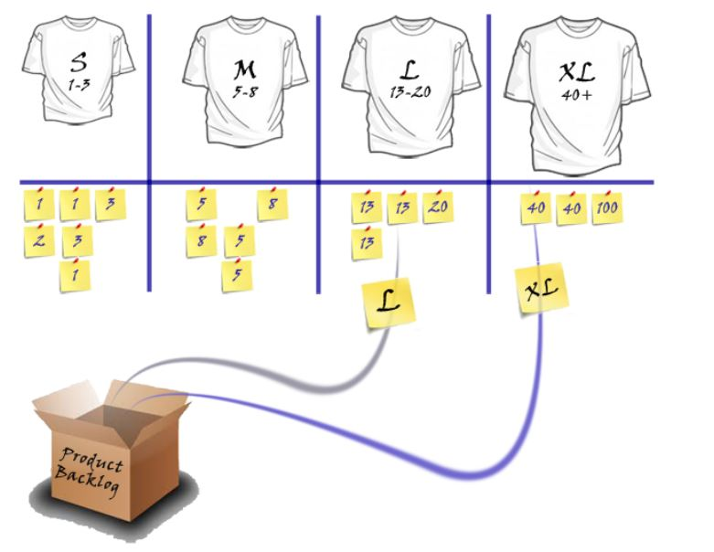 

**Steps**

Make S, M, L, XL Cards

Product Owner will explain the story to be estimated and the development team will ask questions if they have any issues or unclarity. For example,  
  
Design Related- Do we have to learn new things before starting the design/HTML/ j Query etc?  
Coding Related- Do we have any code class library ready or we have to write it from the scratch?  
Testing Related- Any specific setup required for Unit testing?

Each developer gives each story a t-shirt size.

All in Development team will raise their cards simultaneously.

The development team will discuss the differences.

The product owner explains the story further or clarifies misunderstanding if any.

The team will Go back to Step 3-Step5 until all are agree with one size.

Complete or place the stories in size buckets.

Estimate the time to complete all stories in S, M, L, XL buckets.

Smaller Than XS = a Task

Extra Small = 1

Small = 2

Medium = 3

Large = 5

Extra Large = 8

Large than XL = an Epic  
  
 

**Benefits**

This is a very informal strategy and can be utilized quickly with a large number of items.

It is a popular agile relative estimation technique.

Forcing the estimate into one of a fixed set of sizes allows the process to go quickly

It is a good way to Introduce terms to relative estimating.

It is very effective for affinity estimating

T-shirt sizes can be a great way to becoming familiar with relative estimating. So, start with them if your dev team finds that easier.

But However, insignificantly put some fundamental numbers on them (e.g., Medium=5) and after that steadily shift to using the numbers directly.  
  
I hope you like this article. stay tuned for more article on Agile Development. If you have any query, please feel free to post in the comments section. 

3. Give example of Risk mitigation, monitoring and management (RMMM) plan.

[Build up a table.]

**RISK IN SOFTWARE ENGINEERING:**

Risk is some problem that happen in a today for feature. When unwanted and unexpected risk are happened in software which loss your software organization and these types of potential issues which harm your timeline of software and affected your software cost. In an easy word we say that unexpected problems or issues which is linked with software for feature this is called software risks.

### **EXAMPLE**

To ensure that risks remain in the forefront of project management activities, it’s best to keep the risk management plan as simple as possible. For both conventional and agile software project management methodologies, a **risk register** is a proven tool for organizing and referring to known projects risks.

**RISK MITIGATION, MONITORING, MANAGEMENT(RMMM):**

RMMM Stands for Risk Mitigation, Monitoring, Management. Mitigation means proactive approach; Monitoring means project manager and Management means Reactive approach It is consider in software engineering for security. If you’re a project manager and controlling all things in a project off course you want to provide all benefits of your customer and you want that your project is free from any type of risk so you will be used RMMM system for making a project.

**RMMM PLAN:**

Risk Mitigation, Monitoring and Management Plan (RMMM) work on documents. Documents is the part of risk analysis, and it is used by the project manager, team of project and all stakeholders maintained this plan by using database system create, searching information and entry, priority ordering and other analysis may be easy by using this plan. Risk monitoring is a project tracking activity.